**LAPORAN PRAKTIKUM PENGOLAHAN CITRA DIGITAL**

**7. HISTOGRAM EQUALIZATION AND SPECIFICATION**



**Disusun oleh :**

**Nama : Garcia Bryan Farrel**

**NPM : 2327250026**

**Kelas : IF41**

**PROGRAM STUDI INFORMATIKA**

**FAKULTAS ILMU KOMPUTER DAN REKAYASA**

**UNIVERSITAS MULTI DATA PALEMBANG**

**2024**

**TUTORIAL : HISTOGRAM EQUALIZATION AND SPECIFICATION**

**Goal**

The goal of this tutorial is to learn how to use the IPT for (global and local) histogram

equalization and histogram specification (matching).

**Objectives**

* Explore the process of histogram equalization.
* Learn how to use the histeq function.
* Learn how to perform histogram specification (matching).
* Explore the Interactive Histogram Matching demo.
* Learn how to perform local histogram equalization with the adapthisteq function.

**What You Will Need**

ihmdemo.m—interactive Histogram Matching demo M-file

**Procedure**

Let us begin by using the function histeq to perform histogram equalization on our

own images, and by using the imhist function, we can view the histogram of the original and the adjusted image.

1. Display the image pout and its histogram.

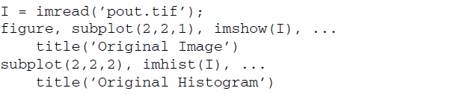

1. Use the histeq function to perform histogram equalization.



|  |
| --- |
|  |
|  |

**Question 1** Why must we include the second parameter (256) in the histeq

function call?

|  |
| --- |
| Karena untuk menentukan tingkat keabuan dalam proses equalized. |

1. Display the equalized image and its histogram.



|  |  |
| --- | --- |
|  |  |

**Question 2** What is the effect of histogram equalization on images with low contrast?

|  |
| --- |
| Bisa diliat kalau low contras akan ada perbedaan seperti pixel nya lebih rapat dapat di lihat pada histogram nya walaupun pada gambar hampir terlihat sama. |
|  |

1. Close any open figures and clear all workspace variables.
2. Execute the following code to perform histogram equalization on the tire image.

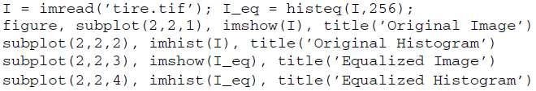

|  |  |
| --- | --- |
|  |  |

**Question 3** Based on the tire image’s original histogram, what can be said about its overall brightness?

|  |
| --- |
| Dengan menembahkan brignest kita dapat melihat gambar ban tersebut lebih terang dari pada original nya. |

**Question 4** How did histogram equalization affect the overall image brightness in this case?

|  |
| --- |
| Menerangkan bagian area gelap pada gambar. |

Histogram equalization does not always perform well. As we will see in the next steps, it depends on the original image.

1. Close any open figures and clear all workspace variables.
2. Perform histogram equalization on the eight image.

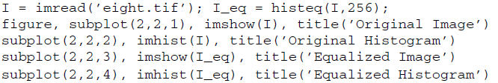

|  |
| --- |
|  |
|  |

**Question 5** Why was there such a loss in image quality after histogram equalization?

|  |
| --- |
| Mungkin karena tidak terlalu ada area gelap, sehingga dipaksa mangknya terjadi loss. |

The transformation function for histogram equalization is simply the cdf of the original image.

1. Display the normalized cdf for the eight.tif image.



**Question 6** What does the cumsum function do in the previous step?

|  |
| --- |
| Untuk menghitung jumlah kumulatif dari histogram tersebut. |

1. The transformation function can also be obtained without using the cumsum function.



|  |  |
| --- | --- |
|  |  |

As we have learned, the histogram equalization process attempts to flatten the image histogram. Histogram specification (also known as histogram matching) tries to match the image histogram to a specified histogram. The histeq function can also be used for this operation.

1. Close any open figures and clear all workspace variables.
2. Prepare a subplot and display original image and its histogram.

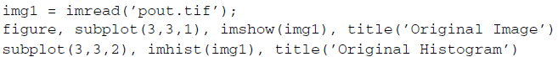

1. Display the image after histogram equalization for comparison.

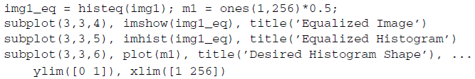

|  |  |
| --- | --- |
|  |  |

1. Display matched image where the desired histogram shape is a straight line from (0, 0) to (1, 1).

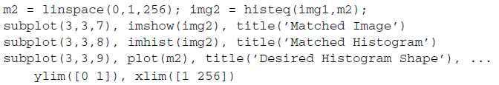

|  |
| --- |
|  |
|  |

As we can see from the previous steps, performing histogram specification means we must generate a function that represents the shape of the desired histogram. The Interactive Histogram Matching demo (developed by Jeremy Jacob and available at the book’s companion web site) shows us how creating a desired histogram shape can be an interactive process.

1. Close any open figures and clear all workspace variables.
2. Run the Interactive Histogram Matching demo.



1. Experiment with creating your own desired histogram shape. To create new points on the function curve, click the curve at the desired location. To move a point, press and drag the point. To delete a point, simply click it.

**Question 7** What does the Continuous Update checkbox do?

|  |
| --- |
| Agar dapat melihat langsung saat kita mengubah parameter. |

**Question 8** How do the different interpolation methods change the shape of the desired histogram curve?

|  |
| --- |
| Menciptakan transisi yang halus antara titik-titik histogram. |

**Question 9** How can the demo be loaded with a different image?

|  |  |
| --- | --- |
|  |  |

Local histogram equalization is performed by the adapthisteq function. This

function performs contrast limited adaptive histogram equalization (CLAHE) and operates on small data regions (called tiles), whose size can be passed as a parameter.

1. Perform local histogram equalization on the coins image.

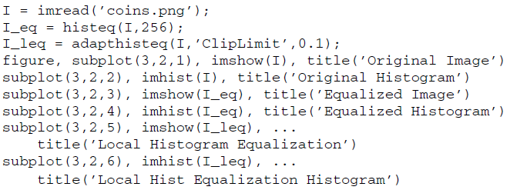

The original image’s histogram is clearly bimodal, which separates the pixels of the background from the pixels that make up the coins. We have already seen how images with bimodal distribution of pixel shades do not perform well under (global) histogram equalization.

|  |
| --- |
|  |
|  |

**Question 10** What does the ClipLimit setting do in the adapthisteq function?

|  |
| --- |
| ClipLimit adalah faktor kontras yang mencegah saturasi gambar yang berlebihan dan fungsi nya pada adapthisteq menentukan batas maksimum kontras lokal sebelum dilakukan clipping. |

**Question 11** What is the default tile size when using adapthisteq?

|  |
| --- |
| Ukuran tile default pada adapthisteq adalah 8x8 piksel. |